University Attendance and Timetable

Management System

Made By: Youssef Shaher Shokry 241015139
Nour Eldein Mohamed 241016883

Problem
Universities often struggle with managing attendance and creating organized timetables. Manual systems lead to errors, schedule conflicts, missing attendance records, and slow reporting. There is no centralized place to track students, instructors, rooms, and course schedules efficiently.

Solution
We designed a database-driven University Attendance and Timetable Management System that centralizes all data. The system manages students, instructors, courses, schedules, rooms, and attendance automatically. Timetables are organized without conflicts, attendance is recorded accurately, and reports can be generated quickly for departments and administrators.

Entities in the System
- Department
- Student
- Instructor
- Course
- Enrollment
- Room
- Attendance
- Semester
- Program
- Schedule
- AttendanceType
- UserAccount
- DepartmentHead

Attributes
1. Department
- department_id (PK)
- name
2. Student
- student_id (PK)
- first_name
- last_name
- email
- department_id (FK)
3. Instructor
- instructor_id (PK)
- first_name
- last_name
- email
- department_id (FK)
4. Course
- course_id (PK)
- course_name
- credit_hours
- department_id (FK)
5. Enrollment
- enrollment_id (PK)
- student_id (FK)
- course_id (FK)
6. Room
- room_id (PK)
- building
- room_number
- capacity
7. Attendance
- attendance_id (PK)
- class_id (FK)
- student_id (FK)
- date
- status (Present/Absent/Late)
8. Semester
- semester_id (PK)
- name (Fall 2025, Spring 2026…)
- start_date
- end_date
9. Program
- program_id (PK)
- program_name
- degree_type (BSc, MSc, Diploma)
10. Schedule
- schedule_id (PK)
- offering_id (FK)
- room_id (FK)
- day_of_week
- start_time
- end_time
11. AttendanceType
- type_id (PK)
- type_name (Present, Absent, Late, Excused)
12. UserAccount
- user_id (PK)
- username
- password_hash
- role (student/instructor/admin)
- linked_id (student_id or instructor_id)
13. DepartmentHead
- head_id (PK)
- instructor_id (FK)
- department_id (FK)
- start_date
- end_date
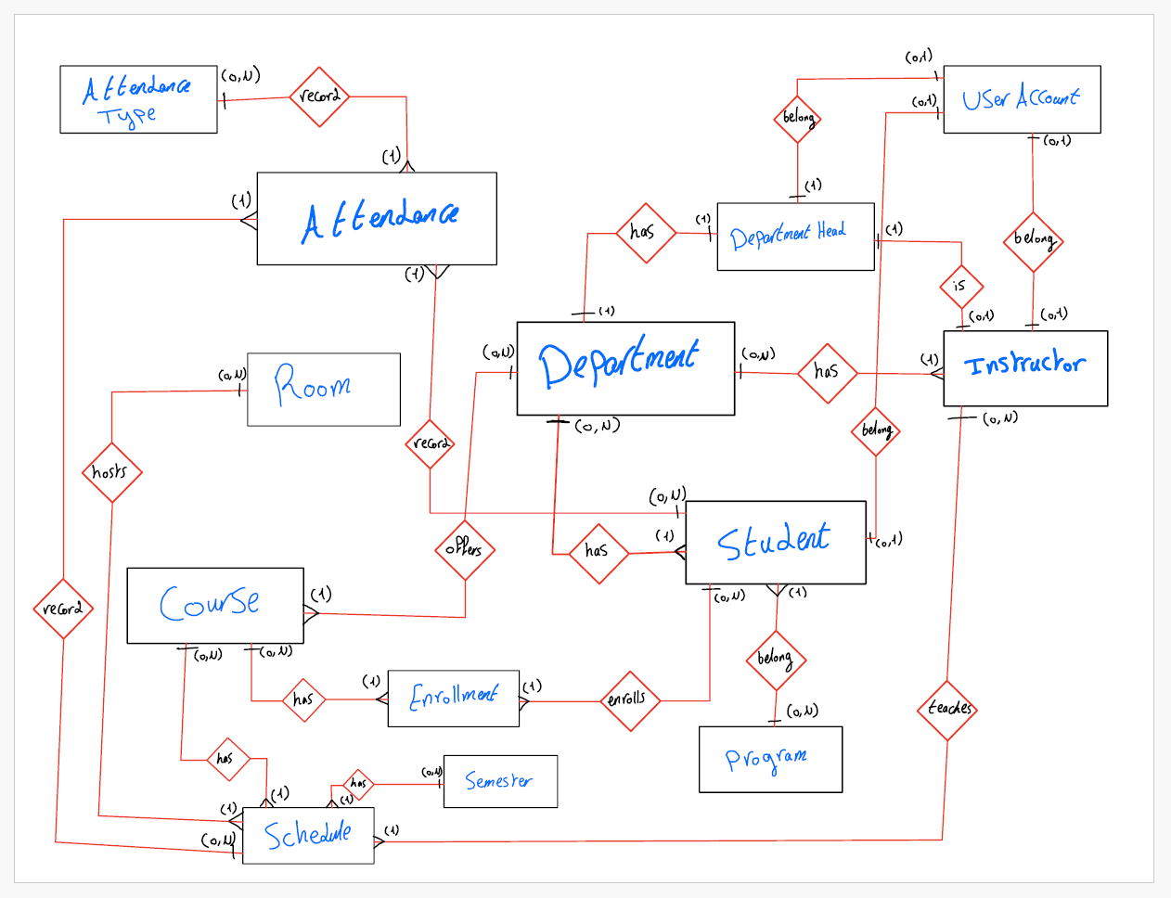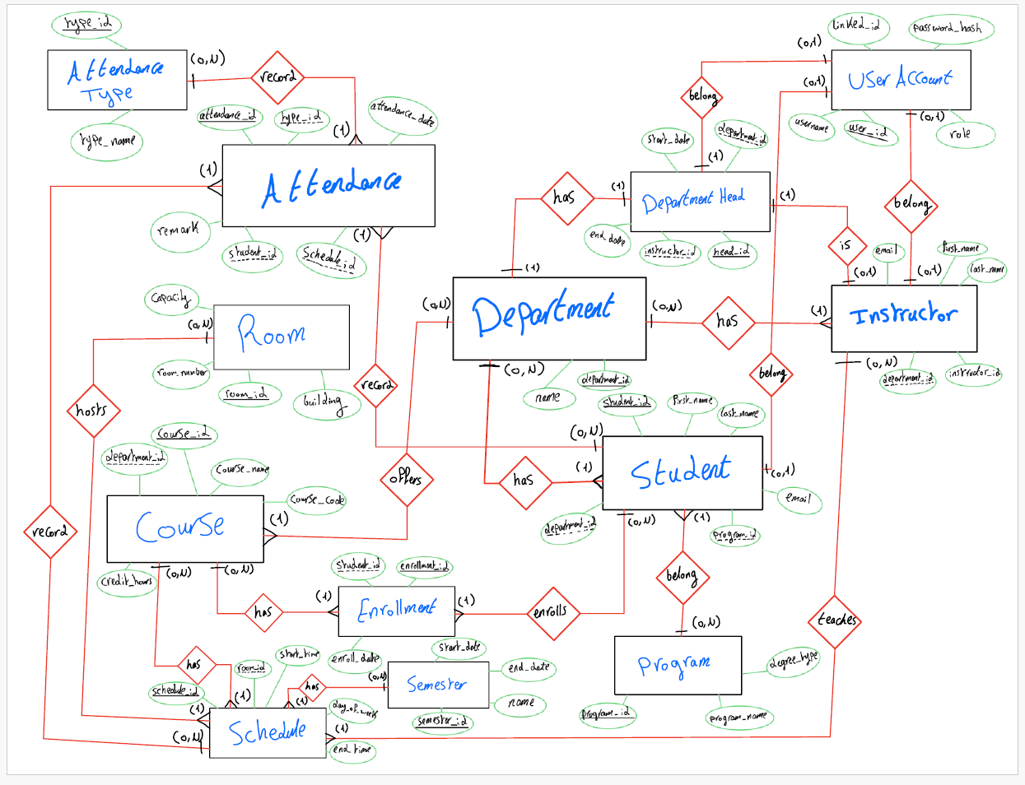
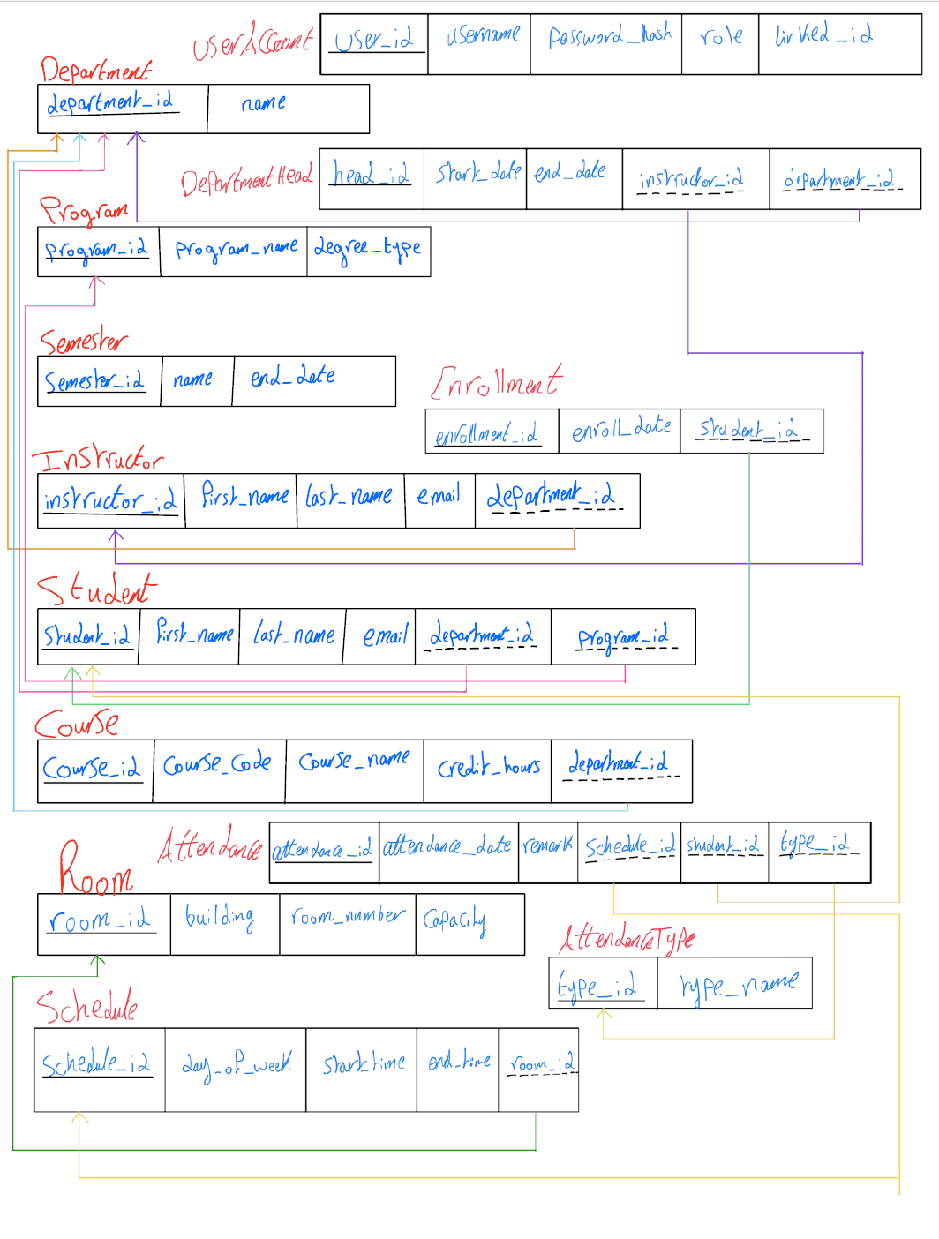
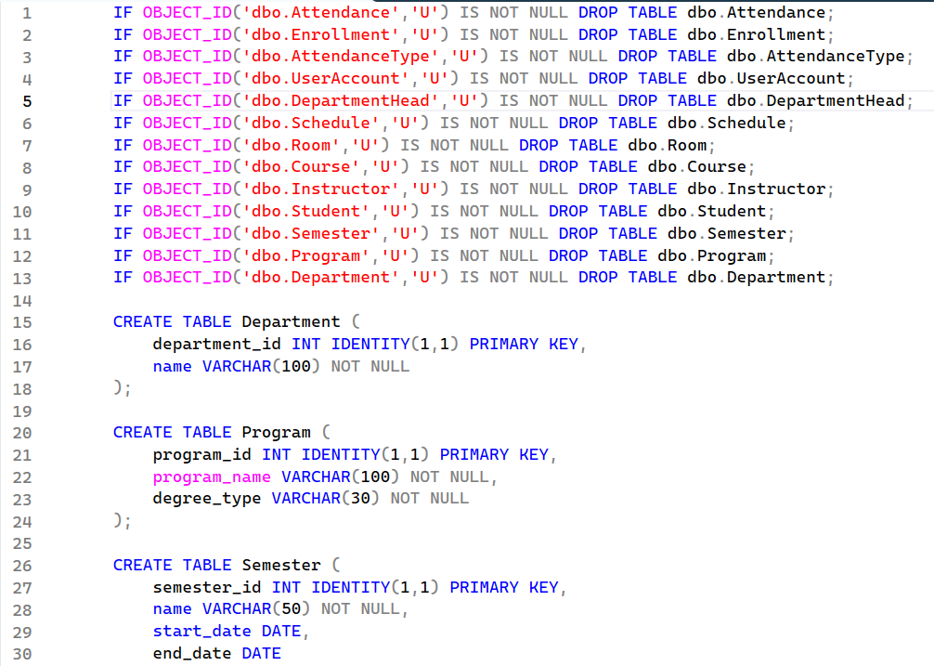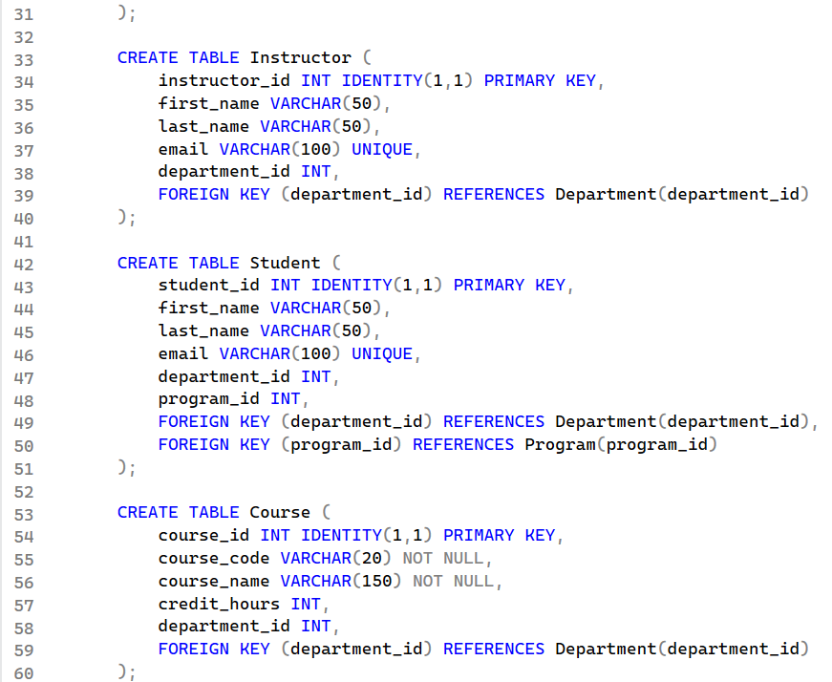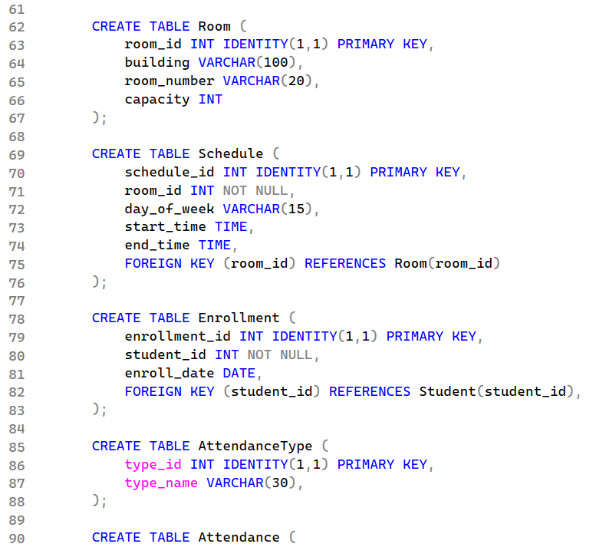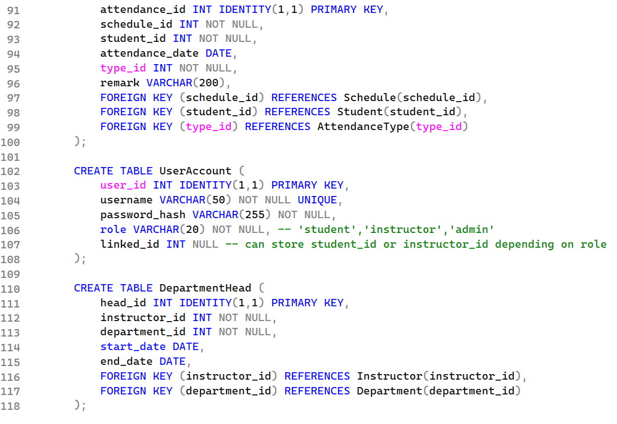
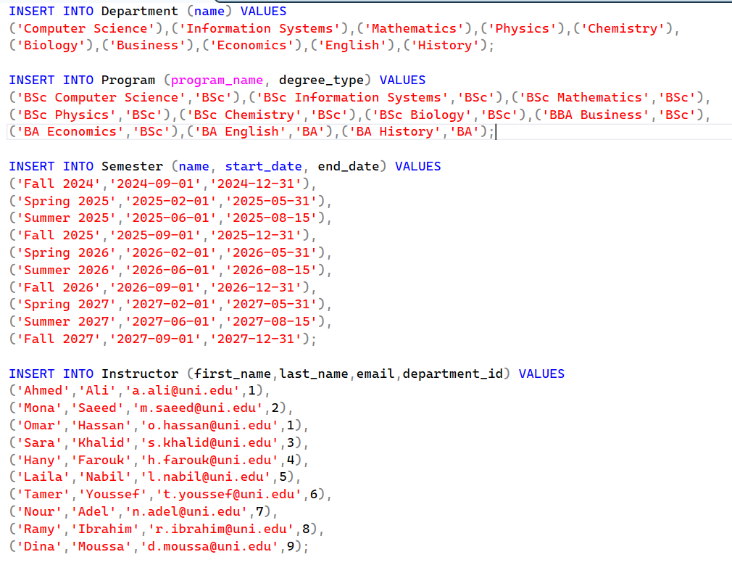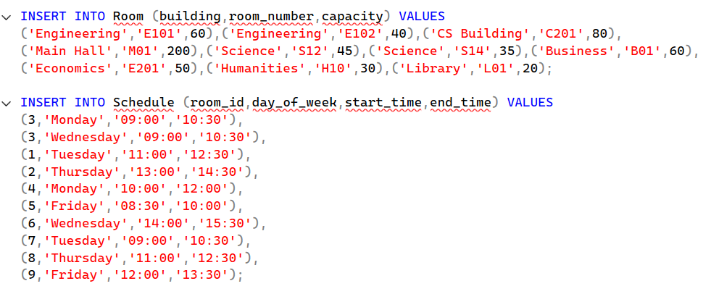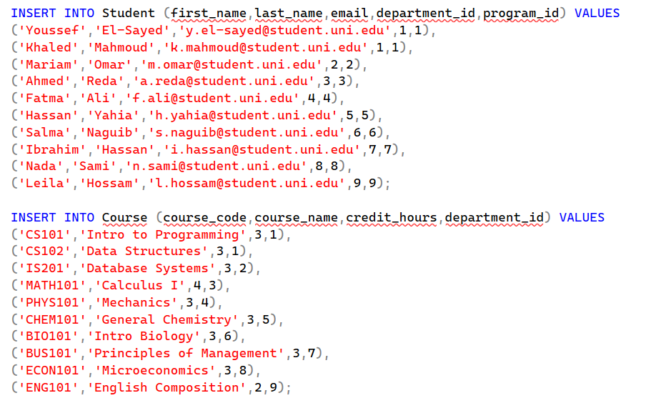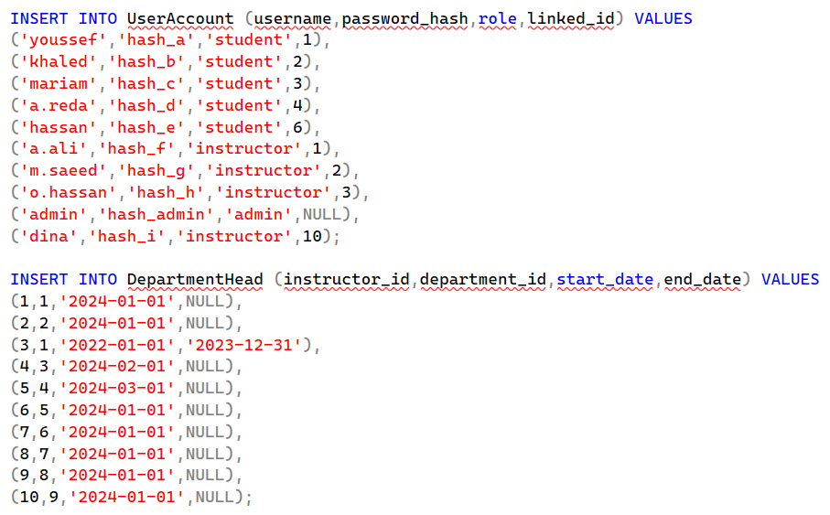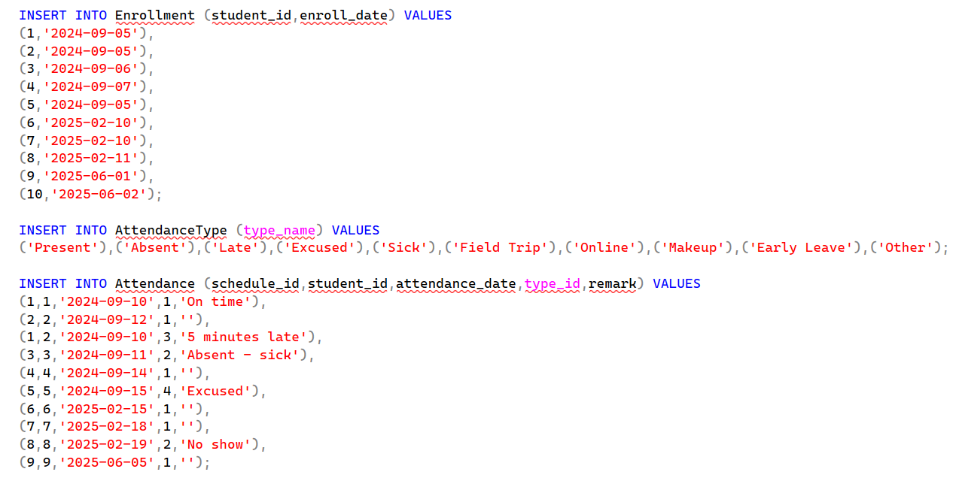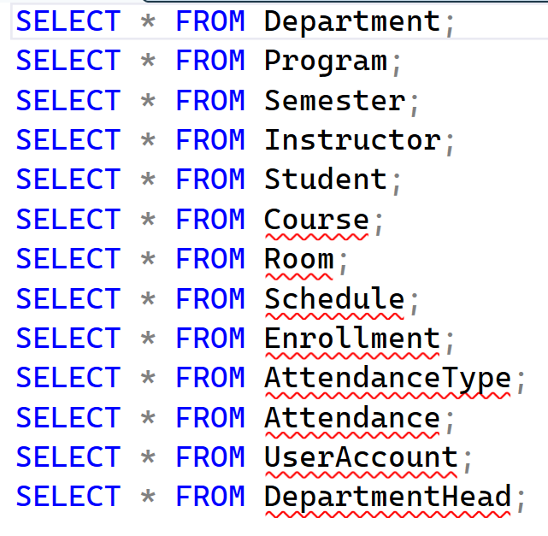
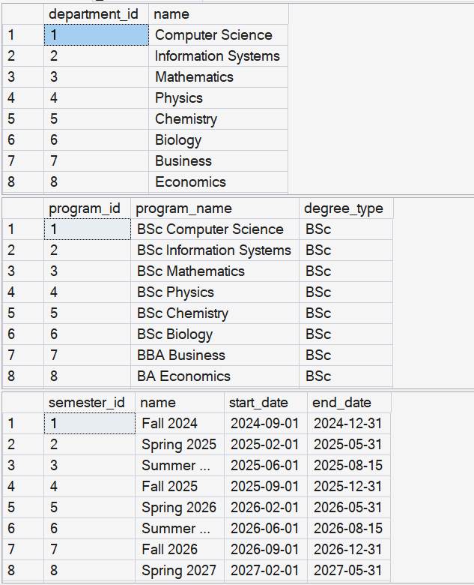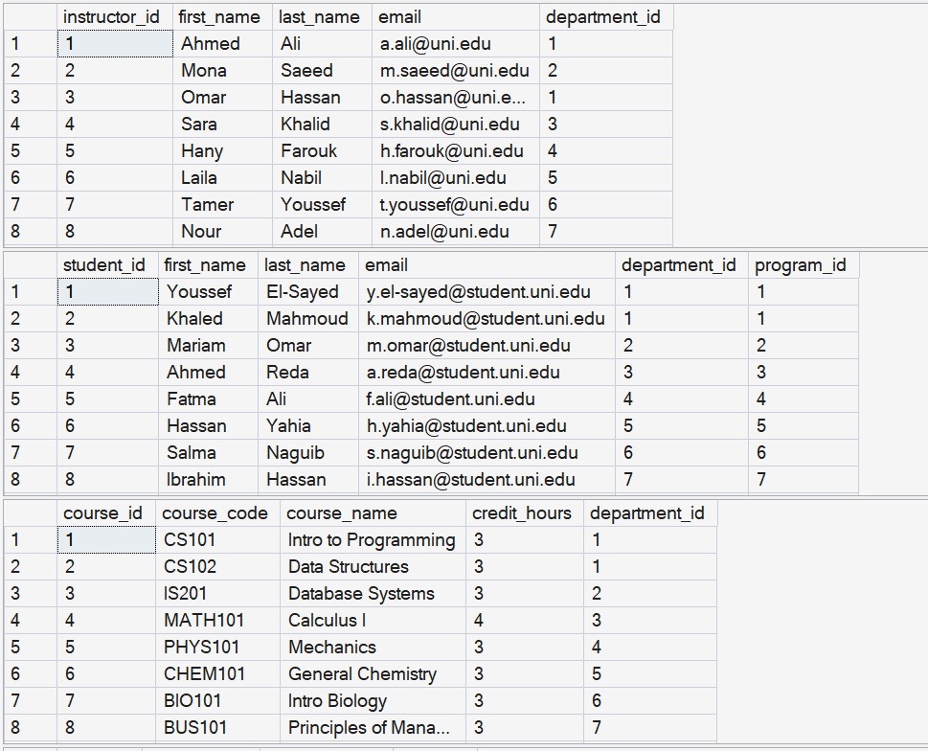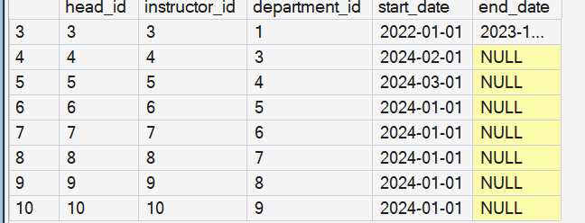

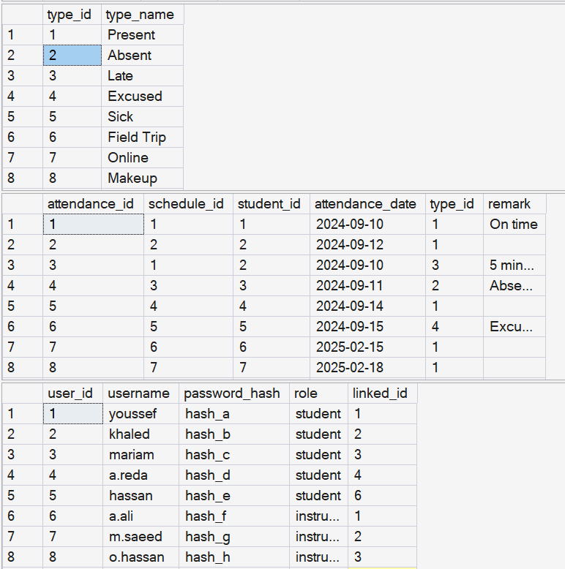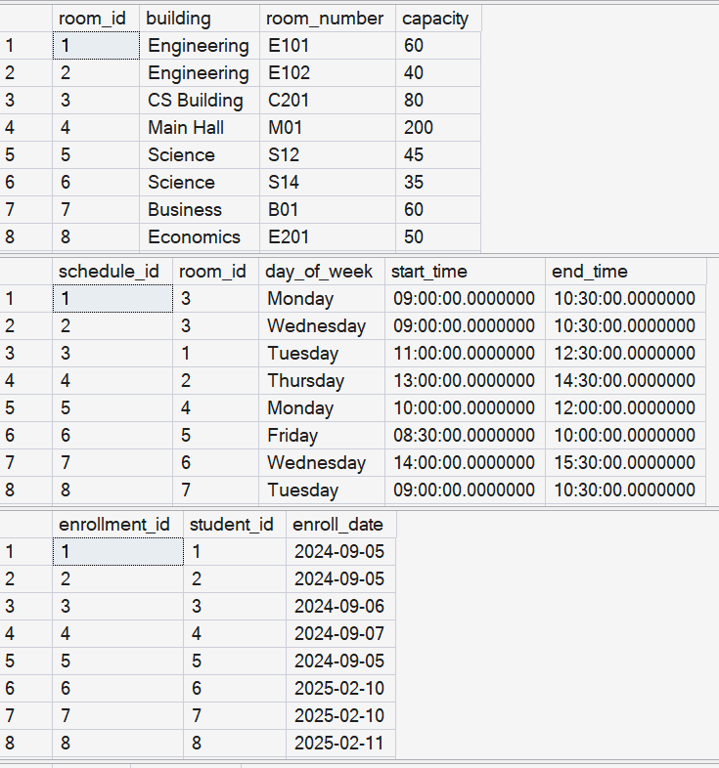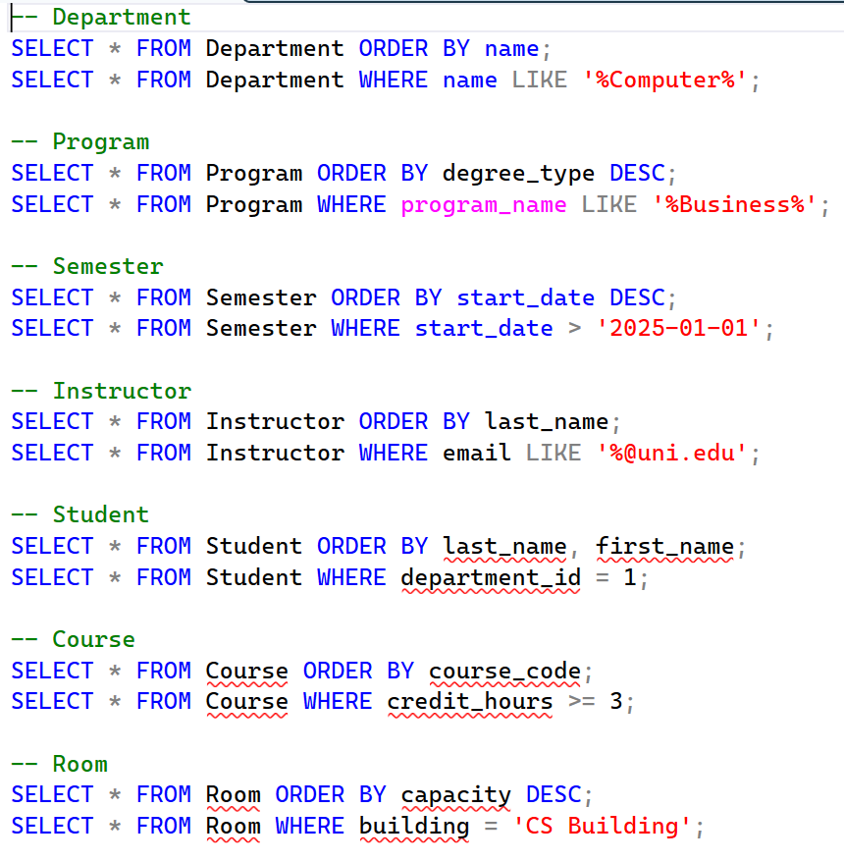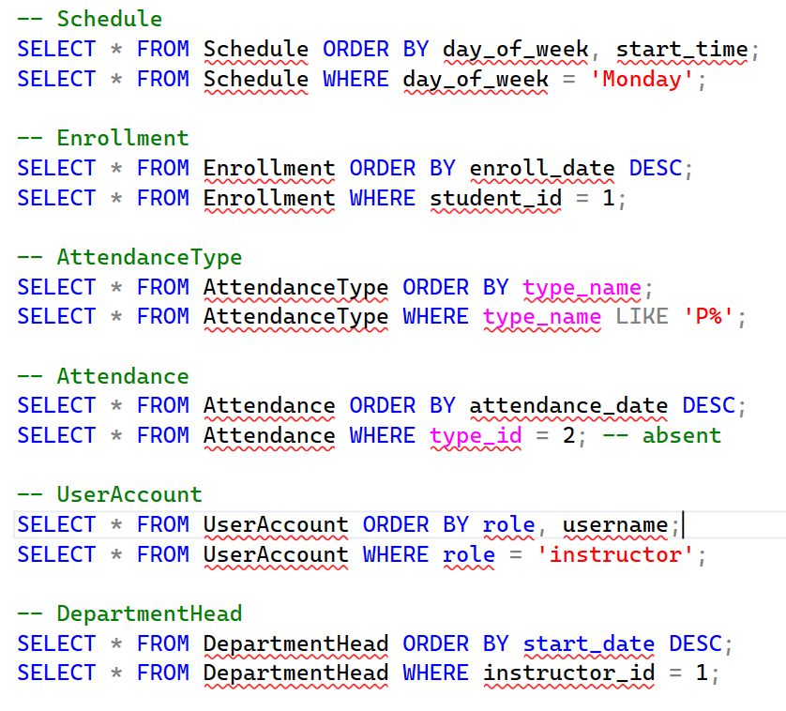
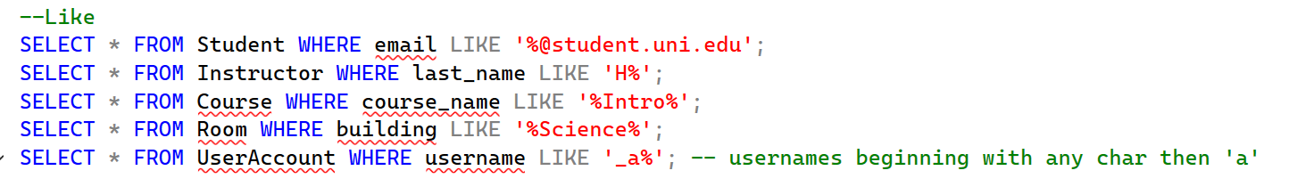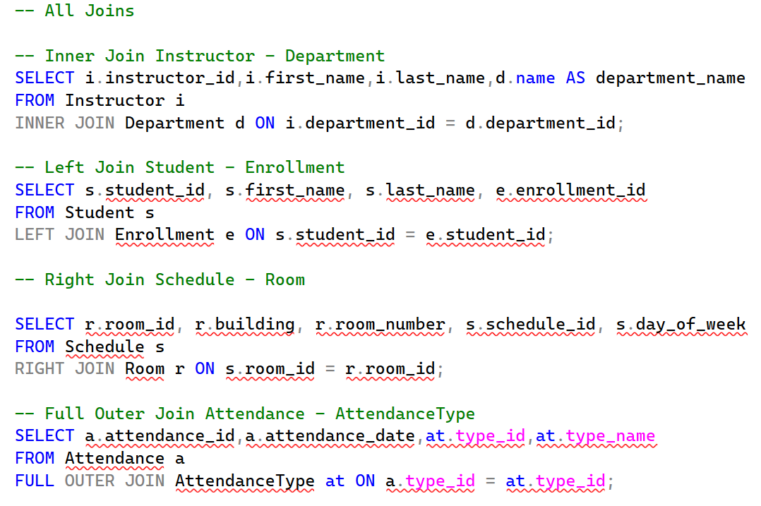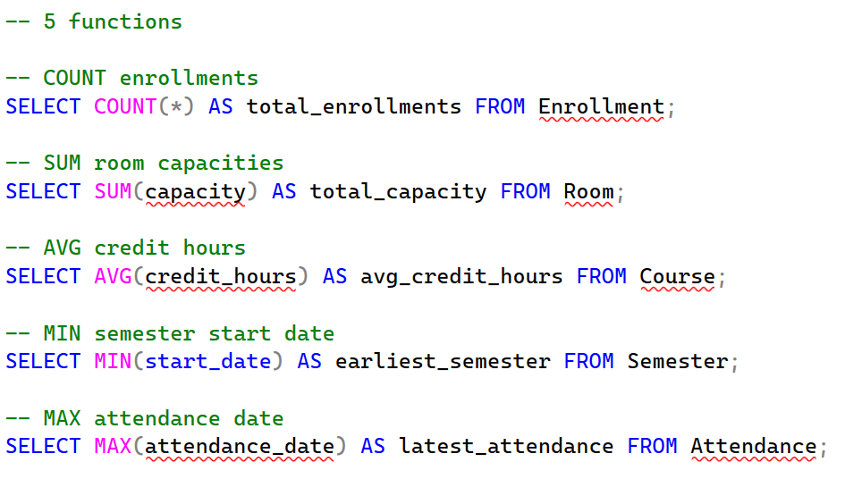
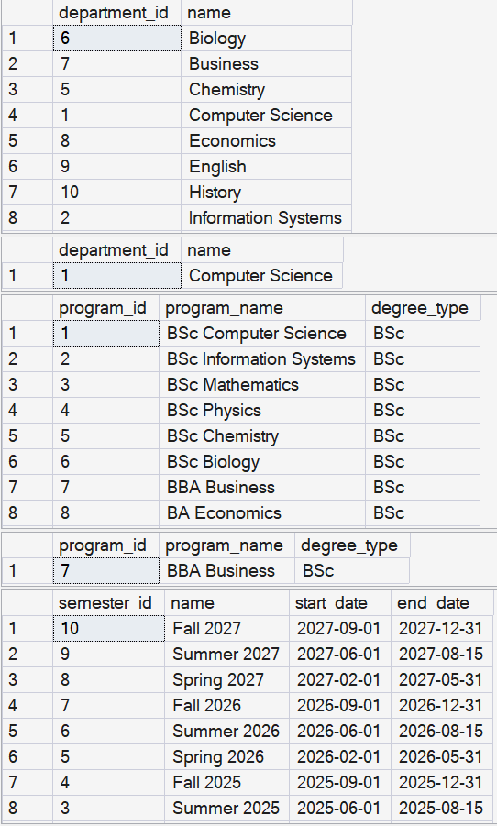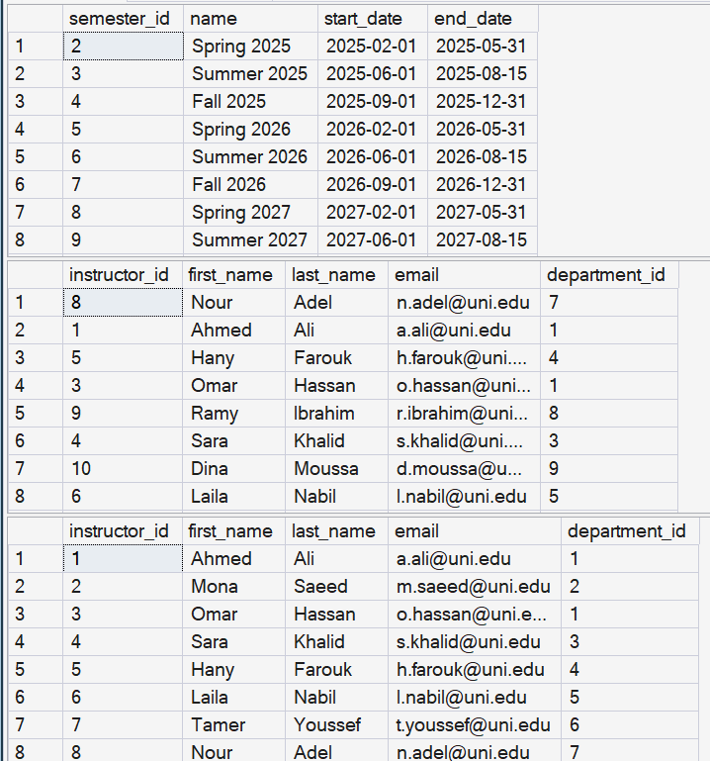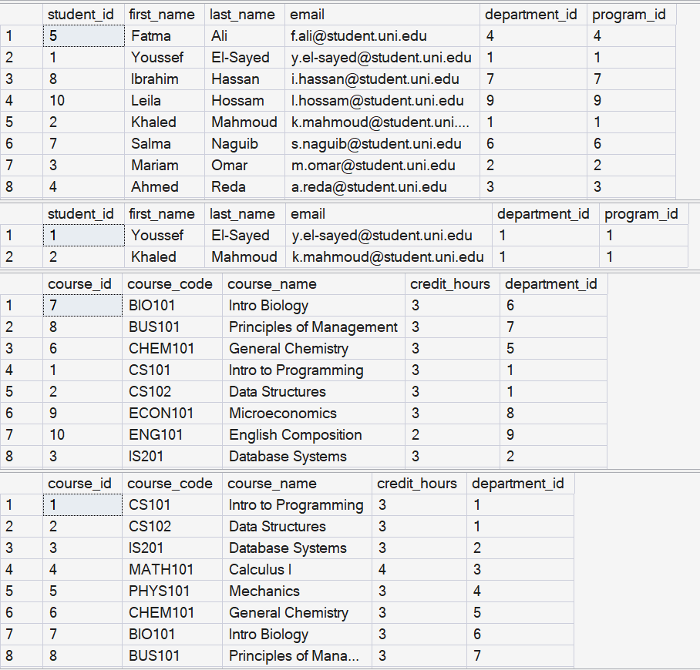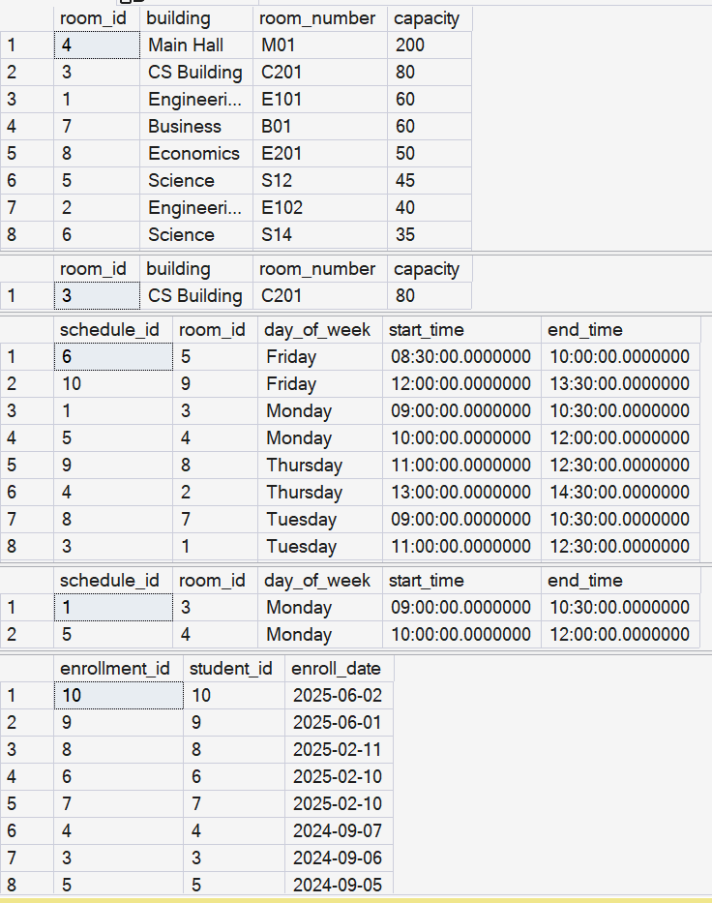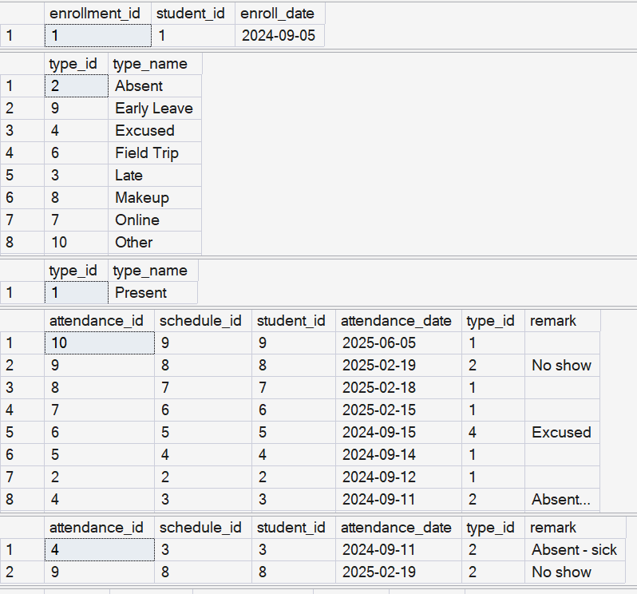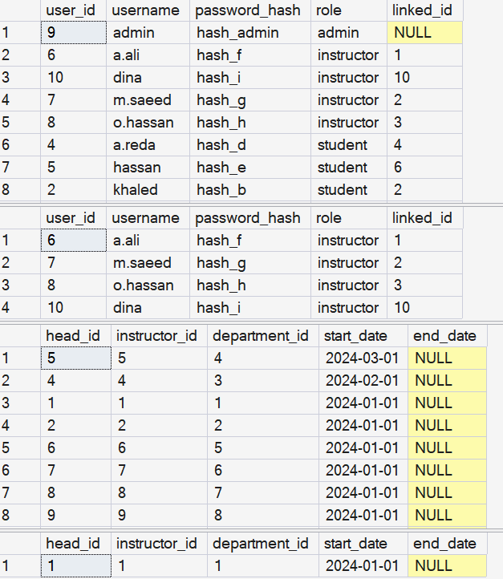

5 string-pattern-matching queries (like condition)

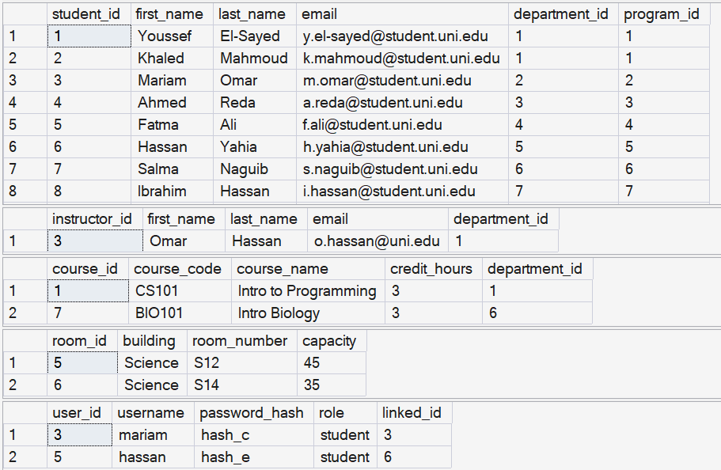

Joins (inner, left, right, full outer)
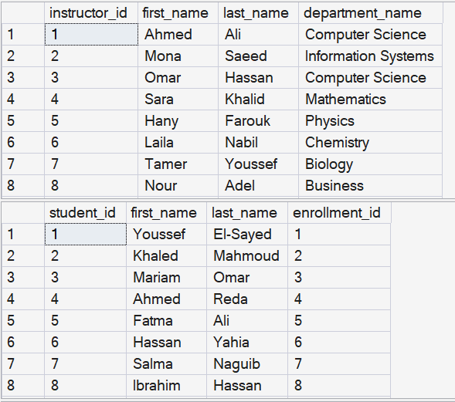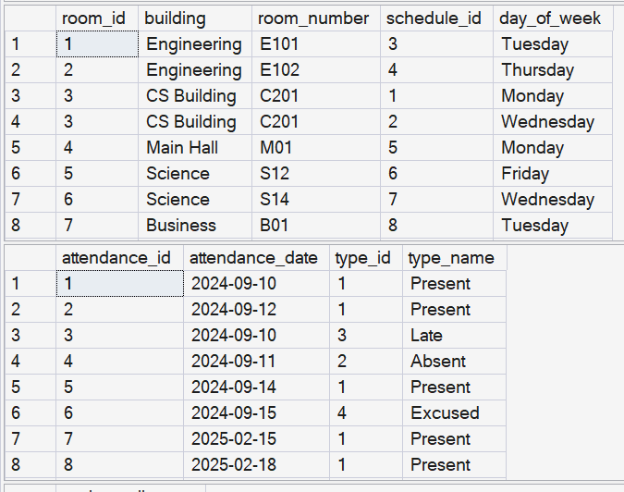

Aggregate functions

